Harnessing EC2, VPC & MobaXterm for Cutting-Edge Entity Hosting

Abstract
This project focuses on leveraging Amazon Web Services (AWS) technologies, specifically EC2, VPC, and MobaXterm, to build secure, scalable, and efficient hosting environments for modern applications. The primary goal is to demonstrate how cloud infrastructure can be utilized to support different real-world scenarios, including secure internal application hosting, high-availability web hosting, and custom application deployment.
In the first scenario, a financial institution requires a highly secure environment to host sensitive applications. This is achieved by deploying EC2 instances within a Virtual Private Cloud (VPC), ensuring network isolation and data protection, while MobaXterm is used for secure remote access and management. The second scenario focuses on an e-commerce platform that demands high availability and performance. Multiple EC2 instances are distributed across availability zones within a VPC to ensure load balancing, fault tolerance, and minimal downtime. In the third scenario, a start-up deploys a custom web application using EC2 within a VPC, providing a flexible and cost-effective hosting solution.
Overall, this project highlights the effectiveness of AWS cloud services in delivering secure, scalable, and reliable hosting solutions while simplifying deployment and management through tools like MobaXterm.

1. Introduction

1.1 Project Overview
The project “Harnessing EC2, VPC & MobaXterm for Cutting-Edge Entity Hosting” is a cloud-based solution designed to provide secure, scalable, and efficient hosting environments using Amazon Web Services (AWS). With the rapid growth of web applications and digital platforms, organizations require reliable infrastructure that can handle security, scalability, and performance challenges.
To address these needs, this project utilizes AWS services such as Elastic Compute Cloud (EC2) for virtual server deployment and Virtual Private Cloud (VPC) for network isolation and security. These services enable organizations to create customized environments tailored to their specific requirements. MobaXterm is used as a remote management tool, allowing secure access and easy administration of cloud instances.
The project demonstrates real-world use cases including secure application hosting for financial institutions, high-availability hosting for e-commerce platforms, and flexible deployment for start-ups. By combining cloud infrastructure with efficient management tools, the system ensures better performance, reliability, and ease of maintenance.

1.2 Objectives
The main objectives of this project are:
- To design and implement a secure hosting environment using AWS EC2 and VPC
- To ensure data protection and network isolation for sensitive applications
- To provide high availability and fault tolerance using multiple EC2 instances
- To enable remote server management using MobaXterm
- To create scalable infrastructure that can handle varying workloads
- To reduce downtime and improve system reliability
- To demonstrate real-world deployment scenarios (finance, e-commerce, start-up)
- To provide a cost-effective and flexible cloud hosting solution
- To simplify deployment, monitoring, and maintenance processes
- To enhance overall system performance and security

Project Initialization and Planning Phase

Problem Statement
With the increasing demand for web applications and digital services, organizations face several challenges in deploying secure, scalable, and reliable hosting environments. Traditional hosting methods often lack flexibility, scalability, and proper security controls, making them inefficient for modern requirements.
Organizations such as financial institutions require highly secure environments to protect sensitive data, but managing such infrastructure on-premises is complex and costly. Ecommerce platforms face difficulties in handling traffic fluctuations, which can lead to downtime and loss of revenue. Start-ups often struggle with limited resources and need costeffective solutions for deploying and managing their applications.
Additionally, managing servers remotely and securely becomes challenging without proper tools. Lack of centralized control, poor fault tolerance, and limited scalability lead to performance issues and inefficient system management. Overall, there is a need for a cloudbased solution that provides security, scalability, flexibility, and ease of management.

Objective, Scope, Description, Impact, and Approach

Objective
- To develop a secure and scalable hosting solution using AWS
- To deploy applications using EC2 within a VPC
- To enable secure remote access using MobaXterm
- To ensure high availability and fault tolerance
- To simplify server management and deployment

Scope
- Applicable for multiple domains:
o Financial institutions (secure hosting) o E-commerce platforms (high availability) o Start-ups (cost-effective deployment)
- Supports scalable infrastructure using cloud services
- Can be extended to large-scale enterprise applications

Description
- Uses AWS EC2 for virtual servers
- Uses VPC for network isolation and security
- Uses MobaXterm for remote access and management
- Provides flexible and customizable hosting environment
- Enables easy deployment and monitoring

Impact
- Improves system security and data protection
- Reduces downtime and increases reliability
- Enhances performance during high traffic
- Provides cost-effective cloud solutions
- Simplifies infrastructure management

Approach
- Deploy EC2 instances inside a VPC
- Configure security groups and network settings
- Use MobaXterm for secure SSH access
- Implement multiple instances for load balancing
- Monitor and manage system performance

Project Proposal (Resource Requirements)

Hardware Requirements
- System with minimum 4–8 GB RAM
- Multi-core processor
- Stable internet connection
- Storage for project files and configurations

Software Requirements
- AWS Account (EC2, VPC services)
- MobaXterm (for remote access)
- Web browser (for AWS console)
- Linux OS (Amazon Linux / Ubuntu on EC2)

Initial Project Planning
- Phase 1: Setup AWS Environment o Create AWS account o Launch EC2 instance o Configure VPC and security groups
- Phase 2: Server Configuration o Connect using MobaXterm o Install web server (Apache/NGINX) o Deploy basic website
- Phase 3: Deployment & Testing
o Host web application o Test using public IP o Ensure proper working
- Phase 4: Advanced Setup o Implement multiple instances o Configure scalability and availability o Optimize performance and security

System Setup and Configuration Phase

Infrastructure Setup
The system setup phase involves configuring the cloud infrastructure using AWS services. Instead of collecting datasets, this project focuses on setting up virtual servers and network environments required for hosting applications. AWS EC2 is used to create virtual machines, while VPC is used to establish a secure and isolated network environment.
The setup begins with launching an EC2 instance, selecting an appropriate operating system (such as Amazon Linux or Ubuntu), and configuring security groups to allow controlled access. A VPC is created to ensure network isolation, along with subnets, route tables, and internet gateways for proper connectivity.

Configuration and Setup Process
- Create AWS account and log in to AWS Console
- Launch EC2 instance
- Choose instance type (e.g., t2.micro)
- Select operating system (Amazon Linux / Ubuntu)
- Configure key pair for secure login
- Set up security groups (allow HTTP, SSH)
- Create and configure VPC
- Attach internet gateway for public access
- Allocate and associate public IP

Server Configuration
- Connect to EC2 instance using MobaXterm (SSH)
- Update system packages
- Install web server (Apache / Nginx)
- Start and enable web server services
- Create project directory (/var/www/html/)
- Upload or create project files (HTML, CSS, JS)
- Set file permissions

Deployment Process
- Place website files inside server directory
- Start web server service
- Access application using public IP
- Test website functionality in browser
- Verify server response and performance

Challenges Faced
- Difficulty in configuring security groups
- Connection issues with SSH
- File permission errors
- Web server not starting initially
- Troubleshooting network access

Solutions Implemented
- Corrected inbound rules (port 22, 80)
- Verified key pair and SSH connection
- Used proper file permissions (chmod)
- Restarted services and checked logs
- Ensured correct IP and URL access

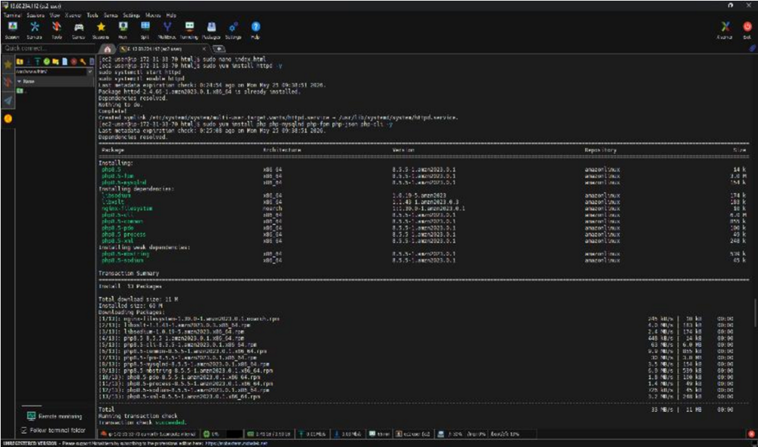
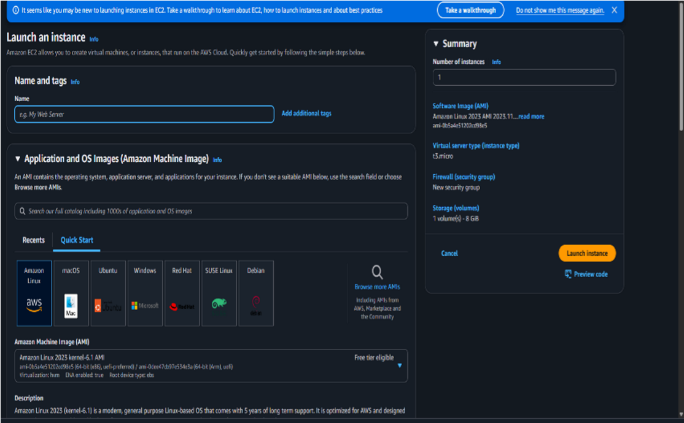
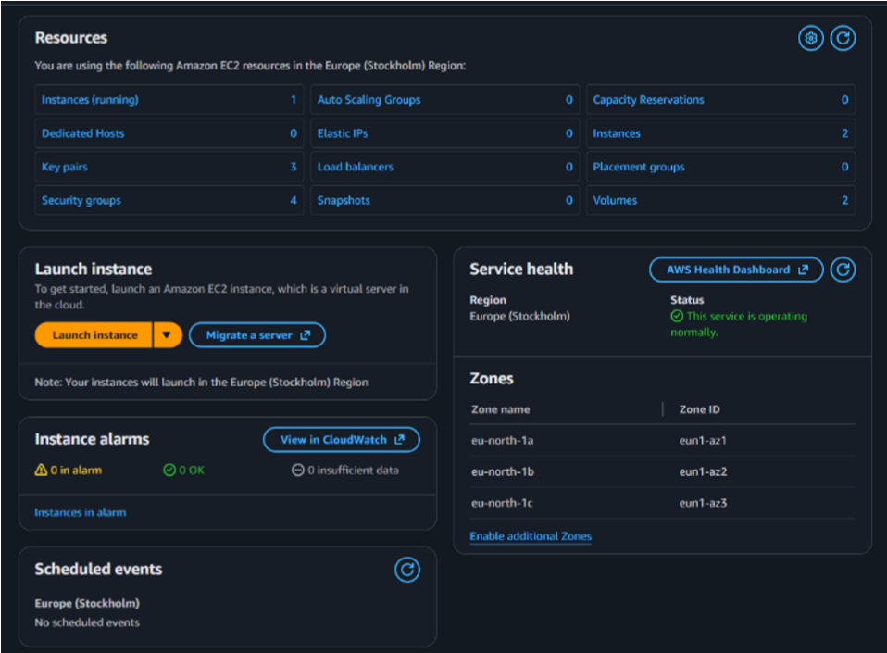
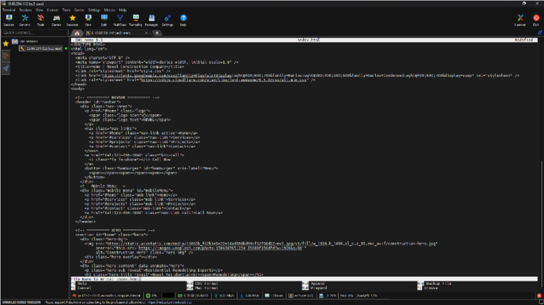
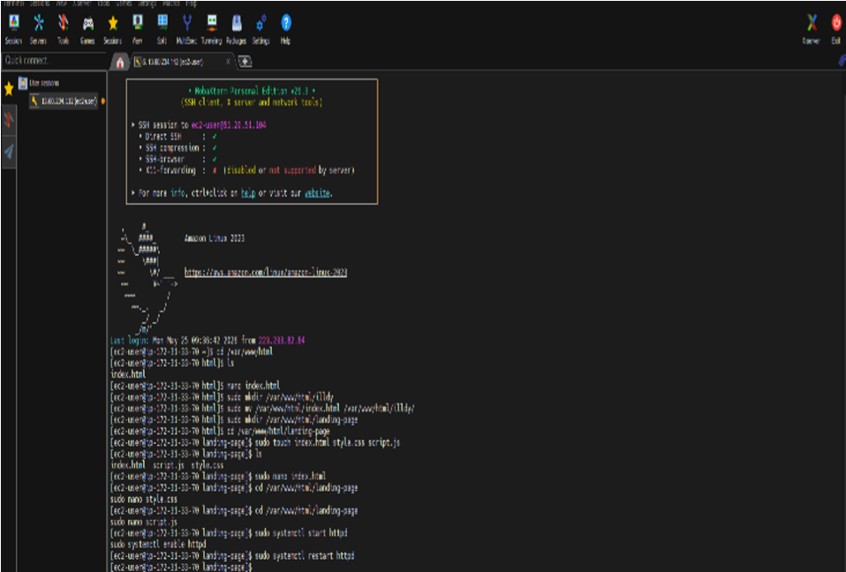
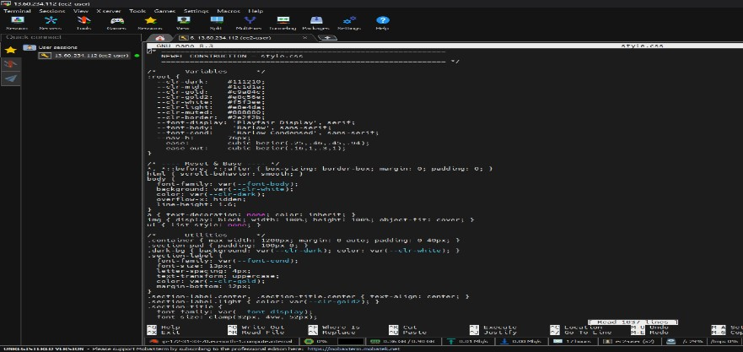
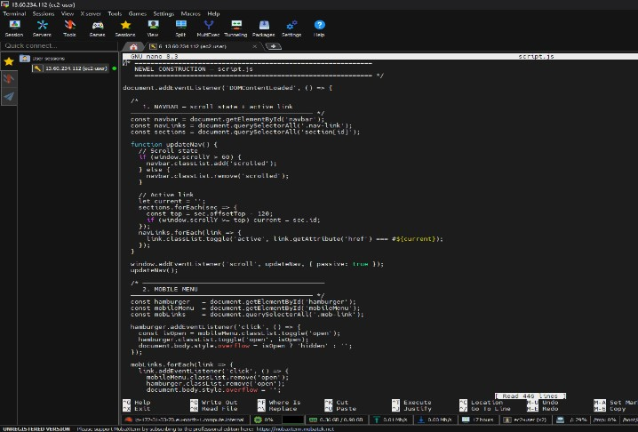
Screen Shotes:
-

System Implementation Phase

Architecture Design (Model Selection Equivalent)
In this project, instead of machine learning models, a cloud-based architecture is designed using AWS services. The system is built using EC2 instances for computation and hosting, along with VPC for secure and isolated networking. Different deployment architectures are considered based on the use case requirements such as security, scalability, and availability.
For secure applications, a single EC2 instance inside a private VPC is used. For highavailability systems, multiple EC2 instances are deployed across different availability zones. For start-up applications, a simple and cost-effective single-instance deployment is used.
The final architecture is selected based on flexibility, scalability, and security, ensuring that it meets the requirements of different real-world scenarios effectively.

Deployment and Testing (Training & Evaluation Equivalent)
The system is deployed by launching EC2 instances and configuring them using MobaXterm. Web servers are installed and configured to host applications. After deployment, the system is tested by accessing the application through the public IP address.
Testing ensures that:
- The server is accessible
- The website loads correctly
- Security settings are properly configured
- Remote access works without issues
The performance and availability of the system are verified under different conditions.

System Optimization and Configuration
- Optimized EC2 instance type based on workload
- Configured security groups for controlled access
- Enabled proper port access (HTTP, SSH)
- Improved server performance by updating packages
- Ensured minimal downtime using proper configurations
- Used efficient directory structure for file management
- Tested scalability by handling multiple requests

Results
The project successfully demonstrates the deployment of applications using AWS EC2, VPC, and MobaXterm. The system provides a secure, scalable, and efficient hosting environment for different use cases.
- Application successfully hosted on EC2 instance
- Website accessible via public IP
- Secure connection established using MobaXterm
- VPC ensured network isolation and security
- System handled requests efficiently
- Deployment process completed successfully

Advantages and Disadvantages
Advantages
- Secure hosting using VPC
- Scalable infrastructure using EC2
- Easy remote management with MobaXterm
- High availability and fault tolerance
- Cost-effective cloud solution
- Flexible deployment for different use cases

Disadvantages
- Requires basic knowledge of AWS services
- Initial setup can be complex
- Costs may increase with scaling
- Dependency on internet connectivity
- Misconfiguration can lead to security risks

Conclusion
This project demonstrates how AWS services such as EC2 and VPC, combined with tools like MobaXterm, can be used to build secure, scalable, and efficient hosting environments. It successfully addresses challenges related to deployment, security, and scalability in modern applications.
The implementation shows that cloud computing provides a flexible and cost-effective solution for organizations of all sizes. By using proper configuration and management techniques, the system ensures high performance, reliability, and ease of maintenance.

Future Scope
- Integration with load balancers for better traffic management
- Use of Auto Scaling for dynamic resource allocation
- Implementation of monitoring tools (CloudWatch)
- Enhanced security using IAM roles and policies
- Deployment using containerization (Docker, Kubernetes)
- CI/CD pipeline integration for automated deployment
- Multi-region deployment for global availability

